Rogene Worley Middle School
Weekly Lesson Plan
2018-2019 School Year
Grade Level: 8 Six Weeks: 5
Week: Dates: 3/23-27/2020
100% EVERY STUDENT EVERY DAY
 | Monday | Tuesday | Wednesday
Conversation | You can call your friends for help if you need to. | You can call your friends for help if you need to. | You can call your friends for help if you need to.
Help | Call friends or email me.  My email is: bobbijogrosvenor@misdmail.org | Call friends or email me.  My email is: bobbijogrosvenor@misdmail.org | Call friends or email me.  My email is: bobbijogrosvenor@misdmail.org
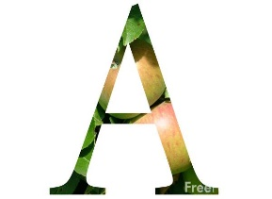Activity  This Photo by Unknown Author is licensed under CC BY-NC-ND | We will plan our 4 years of high school using a variety of tools.  Today we will use our planning sheet that I gave you the Friday before Spring Break. | We will plan our 4 years of high school using a variety of tools.  Today we will use our planning sheet that I gave you the Friday before Spring Break. | We will plan our 4 years of high school using a variety of tools.  Today we will use our planning sheet that I gave you the Friday before Spring Break.
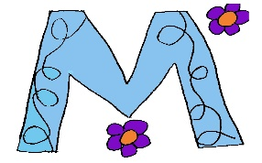

MovemenT
Participation | I will plan my 4 years of high school using the tools that are provided by the teacher.  You will need to be able to access the Ben Barber website to help you plan your classes. | I will plan my 4 years of high school using the tools that are provided by the teacher.  You will need to be able to access the Ben Barber website to help you plan your classes. | I will plan my 4 years of high school using the tools that are provided by the teacher.  You will need to be able to access the Ben Barber website to help you plan your classes.
Signal

 | Thursday | Friday | Notes
Conversation | You can call your friends for help if you need to. | You can call your friends for help if you need to.
Help | Call friends or email me.  My email is: bobbijogrosvenor@misdmail.org | Call friends or email me.  My email is: bobbijogrosvenor@misdmail.org
Activity  This Photo by Unknown Author is licensed under CC BY-NC-ND | We will plan our 4 years of high school using a variety of tools.  Today you will use Xello to input the classes you have chosen. It is important to make sure you do this because this is what the high school counselors will use to create your schedule for next year. | We will plan our 4 years of high school using a variety of tools.  Today you will use Xello to input the classes you have chosen. It is important to make sure you do this because this is what the high school counselors will use to create your schedule for next year.

MovemenT
Participation | I will plan my 4 years of high school using the tools that are provided by the teacher.  Use your paper plan that you created to help you know what to input in Xello. | I will plan my 4 years of high school using the tools that are provided by the teacher.  Use your paper plan that you created to help you know what to input in Xello.
Signal

