Rogene Worley Middle School
Weekly Lesson Plan
2018-2019 School Year
Grade Level: 8 Six Weeks: 6
Week: 6 Dates: 5/18-22/2020
100% EVERY STUDENT EVERY DAY
 | Monday | Tuesday | Wednesday
Conversation
Help
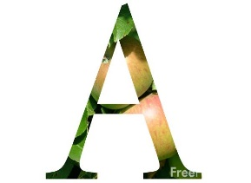Activity  This Photo by Unknown Author is licensed under CC BY-NC-ND | We will produce a digital presentation over our career choice. | We will produce a digital presentation over our career choice. | We will produce a digital presentation over our career choice.
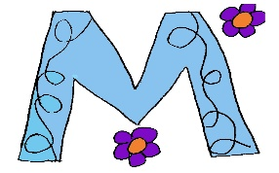

MovemenT
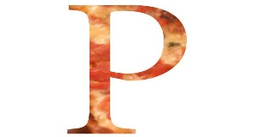Participation | I will create a digital presentation over my career choice.  Note to students and parents: This project is the exam, so it cannot be turned in until Monday of next week! It is due by Thursday of next week. | I will create a digital presentation over my career choice.  Note to students and parents: This project is the exam, so it cannot be turned in until Monday of next week! It is due by Thursday of next week. | I will create a digital presentation over my career choice.  Note to students and parents: This project is the exam, so it cannot be turned in until Monday of next week! It is due by Thursday of next week.
Signal

 | Thursday | Friday | Notes
Conversation
Help
Activity  This Photo by Unknown Author is licensed under CC BY-NC-ND | We will produce a digital presentation over our career choice. | We will produce a digital presentation over our career choice.
MovemenT |  |  | If you need help, email or call me!  bobbijogrosvenor@misdmail.org
Participation | I will create a digital presentation over my career choice.  Note to students and parents: This project is the exam, so it cannot be turned in until Monday of next week! It is due by Thursday of next week. | I will create a digital presentation over my career choice.  Note to students and parents: This project is the exam, so it cannot be turned in until Monday of next week! It is due by Thursday of next week.
Signal

