Rogene Worley Middle School
Weekly Lesson Plan
2018-2019 School Year
Grade Level: 8 Six Weeks: 5
Week: 6 Dates: 4/6-10/2020
100% EVERY STUDENT EVERY DAY
 | Monday | Tuesday | Wednesday
Conversation
Help
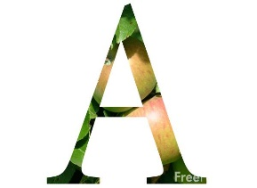Activity  This Photo by Unknown Author is licensed under CC BY-NC-ND | We will use Xello to plan our 4 years of high school. | We will use Xello to plan our 4 years of high school. | We will use Xello to plan our 4 years of high school.
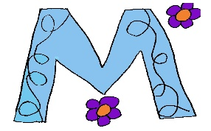

MovemenT
Participation | I will input my class choices for the next 4 years of high school in Xello. | I will input my class choices for the next 4 years of high school in Xello. | I will input my class choices for the next 4 years of high school in Xello.
Signal

 | Thursday | Friday | Notes
Conversation
Help
Activity  This Photo by Unknown Author is licensed under CC BY-NC-ND | We will use Xello to plan our 4 years of high school. | Holiday
MovemenT |  |  | If you need help. Email me!
Participation | I will input my class choices for the next 4 years of high school in Xello.
Signal

