Rogene Worley Middle School
Weekly Lesson Plan
2018-2019 School Year
Grade Level: 8 Six Weeks: 6
Week: 3 Dates: 4/27-5/1/2020
100% EVERY STUDENT EVERY DAY
 | Monday | Tuesday | Wednesday
Conversation
Help
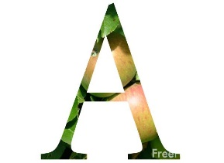Activity  This Photo by Unknown Author is licensed under CC BY-NC-ND | We will explore colleges in Xello. | We will explore colleges in Xello. | We will explore colleges in Xello.
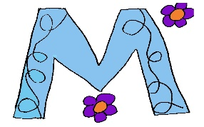

MovemenT
Participation | I will research different colleges in Xello in order to find at least 5 that I am interested in attending after high school.  I will upload my top 5 choices into Canvas. | I will research different colleges in Xello in order to find at least 5 that I am interested in attending after high school.  I will upload my top 5 choices into Canvas. | I will research different colleges in Xello in order to find at least 5 that I am interested in attending after high school.  I will upload my top 5 choices into Canvas.
Signal

 | Thursday | Friday | Notes
Conversation
Help
Activity  This Photo by Unknown Author is licensed under CC BY-NC-ND | We will explore colleges in Xello. | We will explore colleges in Xello.
MovemenT |  |  | If you need help, email or call me!  bobbijogrosvenor@misdmail.org
Participation | I will research different colleges in Xello in order to find at least 5 that I am interested in attending after high school.  I will upload my top 5 choices into Canvas. | I will research different colleges in Xello in order to find at least 5 that I am interested in attending after high school.  I will upload my top 5 choices into Canvas.
Signal

