Rogene Worley Middle School
Weekly Lesson Plan
2018-2019 School Year
Grade Level: 8 Six Weeks: 6
Week: 2 Dates: 4/20-24/2020
100% EVERY STUDENT EVERY DAY
 | Monday | Tuesday | Wednesday
Conversation
Help
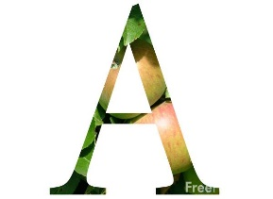Activity  This Photo by Unknown Author is licensed under CC BY-NC-ND | We will study and learn about goal setting. | We will study and learn about goal setting. | We will study and learn about goal setting.
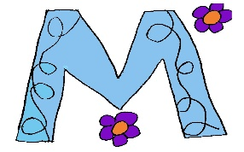

MovemenT
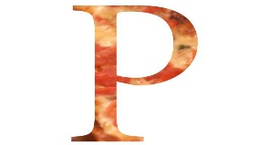Participation | I will read about goal setting. | I will read about goal setting. | I will read about goal setting.
Signal

 | Thursday | Friday | Notes
Conversation
Help
Activity  This Photo by Unknown Author is licensed under CC BY-NC-ND | We will study and learn about goal setting. | We will study and learn about goal setting.
MovemenT |  |  | If you need help, email or call me!
Participation | I will participate in a goal setting online discussion. | I will complete an assessment on goal setting.
Signal

