Rogene Worley Middle School
Weekly Lesson Plan
2018-2019 School Year
Grade Level: 8 Six Weeks: 6
Week: 4 Dates: 5/4-8/2020
100% EVERY STUDENT EVERY DAY
 | Monday | Tuesday | Wednesday
Conversation
Help
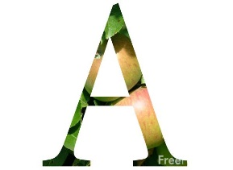Activity  This Photo by Unknown Author is licensed under CC BY-NC-ND | We will research about grants and scholarships. | We will research about grants and scholarships. | We will research about grants and scholarships.
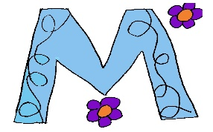

MovemenT
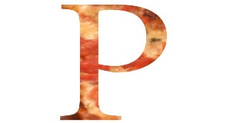Participation | I will read about grants and scholarships and complete a quiz to show that I understood what I read. | I will read about grants and scholarships and complete a quiz to show that I understood what I read. | I will read about grants and scholarships and complete a quiz to show that I understood what I read.
Signal

 | Thursday | Friday | Notes
Conversation
Help
Activity  This Photo by Unknown Author is licensed under CC BY-NC-ND | We will research about grants and scholarships. | We will research about grants and scholarships.
MovemenT |  |  | If you need help, email or call me!  bobbijogrosvenor@misdmail.org
Participation | I will read about grants and scholarships and complete a quiz to show that I understood what I read. | I will read about grants and scholarships and complete a quiz to show that I understood what I read.
Signal

