Rogene Worley Middle School
Weekly Lesson Plan
2018-2019 School Year
Grade Level: 8 Six Weeks: 6
Week: 1 Dates: 4/13-17/2020
100% EVERY STUDENT EVERY DAY
 | Monday | Tuesday | Wednesday
Conversation
Help
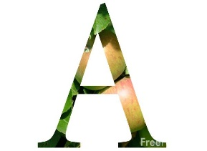Activity  This Photo by Unknown Author is licensed under CC BY-NC-ND | We will use Xello to plan 10th thru 12th grade. | We will use Xello to plan 10th thru 12th grade. | We will use Xello to plan 10th thru 12th grade.
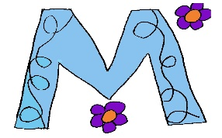

MovemenT
Participation | I will choose my classes for 10th thru 12th grade in Xello. | I will choose my classes for 10th thru 12th grade in Xello. | I will choose my classes for 10th thru 12th grade in Xello.
Signal

 | Thursday | Friday | Notes
Conversation
Help
Activity  This Photo by Unknown Author is licensed under CC BY-NC-ND | We will use Xello to plan 10th thru 12th grade. | We will use Xello to plan 10th thru 12th grade.
MovemenT |  |  | If you need help, email or call me!
Participation | I will choose my classes for 10th thru 12th grade in Xello. | I will choose my classes for 10th thru 12th grade in Xello.
Signal

